Sprint 1 Retrospective
  - Project Preparation and Planning
Project: Ako MSE800
Sprint: SCRUM Sprint 1 | Period: 16–19 October 2026
Jira status: Active | Current task completion: 6/6 (100%)

1. Sprint Overview

Sprint Goal
Establish the project foundation by finalising requirements, defining the MVP scope, configuring project management tools, confirming team responsibilities, and preparing the technical architecture and development environment.
Sprint 1 focused on project preparation rather than software feature development. The work covered requirements and scope, Scrum planning, and technical preparation. All six associated preparation tasks are currently marked Done in Jira.

Sprint 1 Task Summary
Jira Key | Task | Assignee | Status
AKO-26 | Finalise requirements and acceptance criteria | Pei | Done
AKO-27 | Configure Jira Scrum project and backlog | Leon | Done
AKO-28 | Define MVP scope and prioritise stories | Sandhya | Done
AKO-29 | Prepare Sprint plan and team responsibilities | Leon | Done
AKO-30 | Document technical architecture and technology choices | Shuohui Liu | Done
AKO-31 | Establish GitHub repository and collaboration rules | Shuohui Liu | Done
Data note: Sprint 1 remains Active in Jira. The 100% figure reflects current statuses, not a formal Sprint closure snapshot.

Statistical Charts
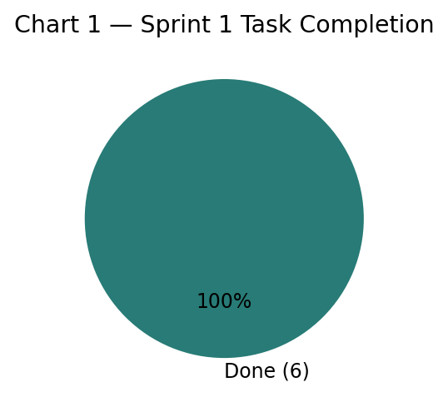
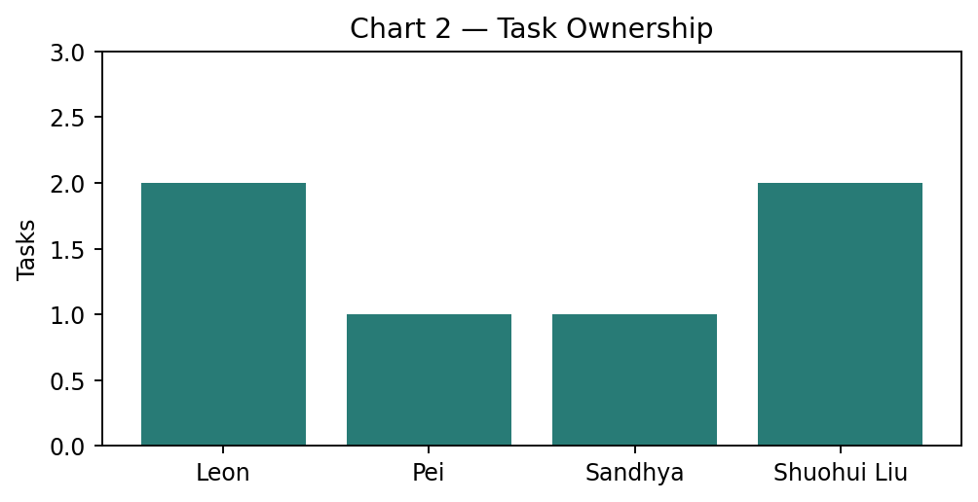
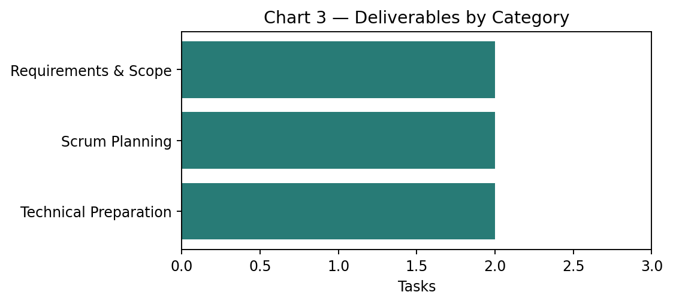
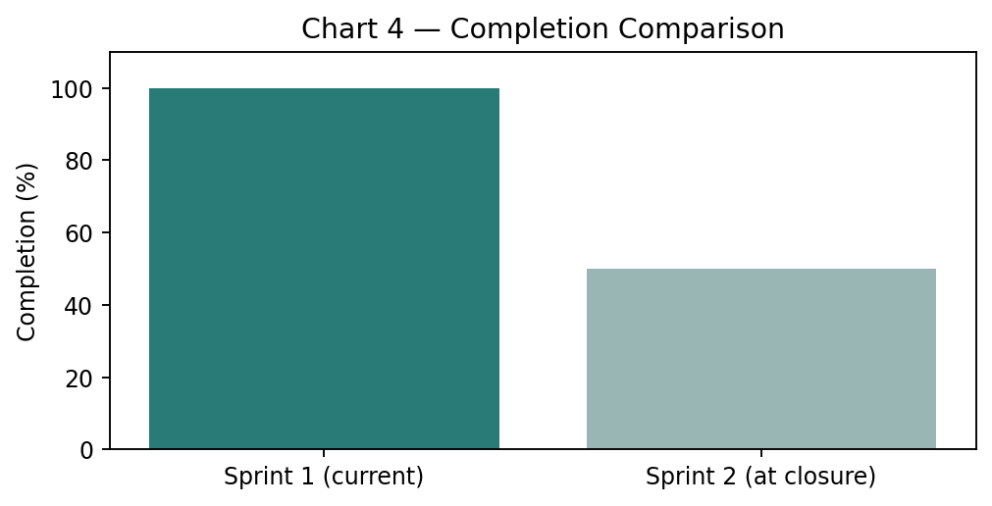
Comparison note: Sprint 1 is a current snapshot; Sprint 2 is measured at closure. Their work types differ, so the comparison is not a productivity ranking.

2. What Went Well
- Requirements and MVP Scope: The team finalised the main requirements, acceptance criteria, and MVP priorities, creating a clear baseline for development.
- Scrum Project Setup: Jira was configured with a backlog, stories, and Sprint planning arrangements.
- Team Responsibilities: Responsibilities for coordination, requirements, communication, and technical work were clarified.
- Technical Preparation: Architecture decisions and GitHub collaboration practices were documented.
- Sprint Progress: All six preparation tasks reached Done status.

3. What Didn’t Go Well
- Initial Tool Familiarisation: Learning Jira, GitHub, and the agreed workflow required additional time.
- Requirements Clarification: Several requirements needed discussion and refinement before agreement.
- Technical Learning Curve: The selected architecture and development environment required investigation.
- Planning Coordination: Aligning priorities, ownership, and technical arrangements took multiple discussions.

4. Lessons Learned
- Clear Requirements First: Confirm requirements and acceptance criteria before implementation.
- Defined Responsibilities: Explicit task ownership improves accountability.
- Consistent Development Standards: Agree on branching, coding standards, and integration procedures early.
- Manageable Subtasks: Break large stories into trackable subtasks.
- Regular Communication: Discuss blockers and uncertainties early.

5. Action Items
Action | Responsible
Maintain Jira Backlog and monitor Sprint progress | Leon
Clarify acceptance criteria and testing requirements | Pei
Confirm priorities and communicate outstanding requirements | Sandhya
Support technical integration and GitHub standards | Michael / Technical Team
Break development stories into subtasks | All Team Members
Keep Jira statuses up to date | All Team Members

6. Next Sprint Improvements
- Implement prioritised MVP stories according to the Sprint plan.
- Follow the agreed architecture and GitHub workflow.
- Use subtasks for transparent development tracking.
- Identify technical blockers and dependencies early.
- Start testing and review throughout the Sprint.
- Keep Jira current and maintain regular team communication.

7. Conclusion
Sprint 1 established the foundation for the Ako MSE800 project. All six preparation tasks currently show Done status, covering requirements, MVP scope, Scrum planning, team responsibilities, technical architecture, and GitHub collaboration. The team is positioned to move into core MVP development in Sprint 2.
Review note: Qualitative observations and action items are proposed retrospective content and should be confirmed by the team. Jira task ownership and technical team responsibilities should be reconciled before final sign-off.

